PYTHON casting

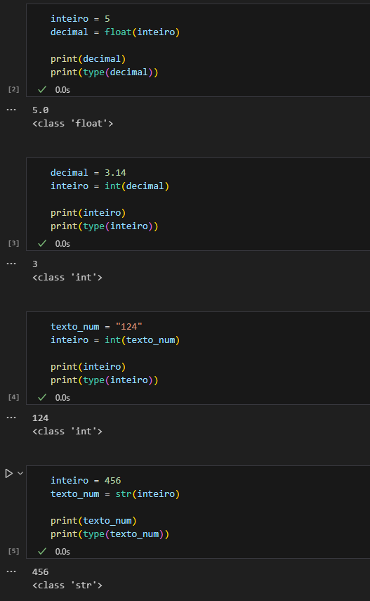

Python is an object-oriented language, so there are times when you'll need to specify which variable its type is. To do this, you can do a 'casting' and convert your *data type*

These are just basic examples, Casting can be useful and necessary in various situations!!